Printing Labels for Court of Honor presentations

Log into TroopMaster.

Under Reports > Advancement > Court of Honor w/4403

Update the dates so that the start date is before the previous Court of Honor. If you have the awards from the last court, check the second radio button. If you need to reprint awards that weren’t presented, click the first radio button.

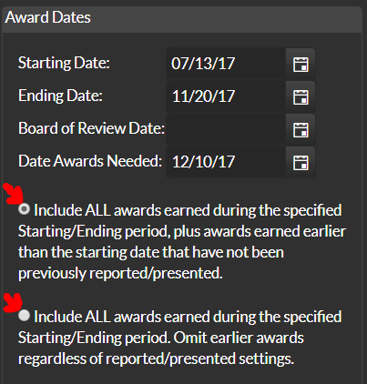

Then click the CSV export



An alert will popup, click the link to download the CSV file, and save it to the desktop.

Next, open Microsoft Word. Click “Blank Document” if the template screen comes up.

Click the “Mailings” tab, then click the small dropdown under “Start Mail Merge”.

Click the “Step-by-Step Mail Merge Wizard…”

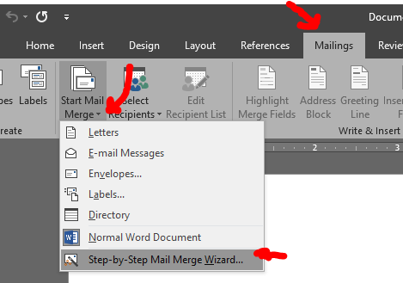

The Wizard will open on the right. Select Labels, then click “Next”

Keep “Change document layout”, then click “Label Options”.

Typical label is Avery US Letter 8160

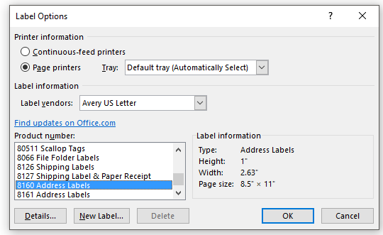

After clicking OK, click “Select Recipients” in the Wizard.

Keep the selection, “Use an existing List”. Then click the “Browse” link.

Select the file on the desktop you exported from TroopMaster “COHExport.CSV”

Make sure the comma and Enter are selected for Import, then click OK

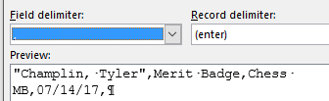

A screen will pop up showing the data. You do not have to change anything here. Just click OK.

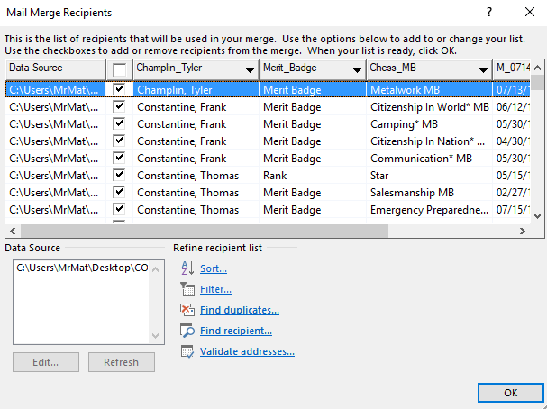

In the Wizard, click the “Next: Arrange your labels” link.

Make sure the cursor is on the first label, then click “More Items” in the Mail Merge.

Select the fields you want on the label and click Insert.

Make sure the formatting in the cell matches what you want, then click “Update all labels” in the Wizard.

My Label looks like this:

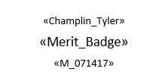

Then click “Next: Preview your labels” This will give you an idea of how it will look.

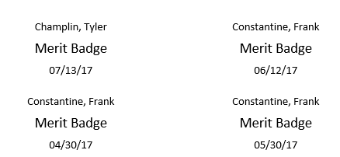

If everything looks good. Click the “Next: Complete the merge”

You can now print the labels.